A193-Afr-Egy-Amulet-Hathor-Late period, 525-334 BCE**-Blue Faience**

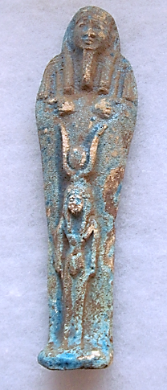 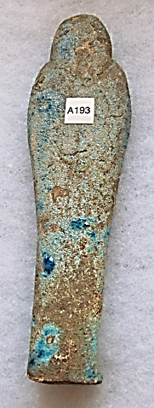

**Case No.: 2**

**Accession Number: A183**

**Formal Label: Anubis Amulet** Late period, 525-334 BCE, Hieroglyphs, **Faience,**

**Display Description:** This blue faience amulet represents Hatho**r** (*[ḥwt-ḥr](https://en.wiktionary.org/wiki/%E1%B8%A5wt-%E1%B8%A5r" \o "wikt:ḥwt-ḥr) “mansion of hathor”:* ) who represents feminine love and motherhood as she was a cow goddess and provider of milk for children and through her knowledge of parturition she was of assistance in childbirth. She is often depicted as “Mistress of the West,” who welcomed the dead into the next life and so was an appropriate subject for an amulet for the grave. As the cow goddess in her anthropomorphic form she is depicted with a sun disk between her two horns sprouting from her head.

The Ushabti has a plain lappet wig terminating in a single band. He carries two whips in his opposed hands without sleeves of an overseer.

**Date or Time Horizon:** Late period, 525-334 BCE.

**Geographical Area: Dendera, Egypt**

**Map, GPS Coordinates:** 26.14207 32.67034; 26º08'31.46" N 32º40'13.23" E



**Cultural Affiliation:** Late Period, Egypt, 525-334 BCE.

**Geographical Area: Temple of the Goddess Hathor, Dendera, Egypt**

**Medium:** Faience

**Dimensions: H 156.71 mm, 6.17 in  
Weight: 127 gm; 4 3/8 oz.**

**Provenance: old European collection**

**Condition: original**

**Discussion:**

This amulet is possibly from the chief repository for knowledge of the rituals and festivals of Hathor in the Late period is her huge and well-preserved temple at Dendera.  Amulets are believed to confer some advantage to the wearer. Perhaps by having this Hathor amulet buried with the deceased some advantage welcoming the deceased to the life Hereafter would have accrued to the owner.

**References:**

Andrews, Carol. 1994. *Amulets of Ancient Egypt*. Austin: University of Texas Press.

Coulson, William D. E. and Albert Leonard. 1996. *Cities of the Delta Pt.1, Naukratis. preliminary report on the 1977-78 and 1980 seasons.* Malibu.

Janes, Glenn. 2002*. Shabtis, a private view: ancient Egyptian funerary statuettes in European private collections*; photography Tom Bangbala. Paris : Cybèle.

Petrie, W.M. Flinders. 1914. *Amulets*. London: Constable & Company.

Petrie, W. M. Flinders. 1935. *Shabtis. Illustrated by the Egyptian collection in University College, London.* London: University College.

|  |
| --- |
| Schneider, Hans D. 1977. *Shabtis - An Introduction to the History of Ancient Egyptian Funerary Statuettes. With a Catalogue of the Collection of Shabtis in the National Museum of Leiden*. 3 volumes. Leiden: Rijksmuseum van Oudheden Te Leiden. |